Get 500-Internal server error for the following modules:

Our Company->Features

Employee->Employee Contract

Food Safety-Temperature control

Follow Up-SJA Form

Control-Temperature Control

Control-SJA Form

Employee-Employee Course

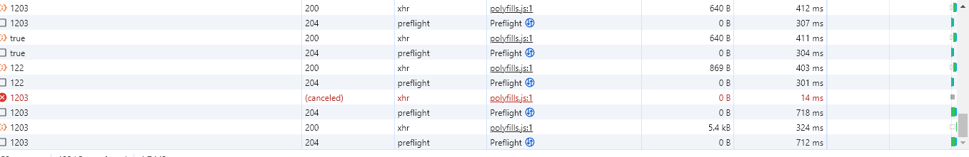



Employee-Employee Contract

Follow Up-SJA Form

Food Safety-Temperature control

Control-Temperature Control

Control-SJA Form

Our Suppliers- When we click on any name.

Our Suppliers- When we click on New Supplier

